Lab 8: PENDULUM MOMENT OF INERTIA

EEE4514

Marcel 1, 2017

**Gabriel Stroe**

# Filtering

## Overview

The purpose of this lab is to fine the moment of inertia of a pendulum analytically and experimentally. In this lab we will calculate what the moment of inertia should be and we will test the result using the output of the system.

## Theory and Methods

From the lab manual we can use the following integration:

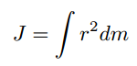

Which can be resolved into Jp = 1/3(Lp2Mp). Mp being the mass of the pendulum which is 0.024 Kg, and Lp being the length of the of the pendulum which is 0.129 m. From this we can calculate the moment of inertia as Jp = 0.0001364 Kgm2

Using this equation:

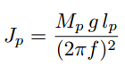

We can calculate the frequency of f as f = 1.6989 Hz.

Next we will set the pendulum in motion and use the points on the graph to calculate these same values.

## Results

After taking in the output of the pendulum swinging we produce the following graph.

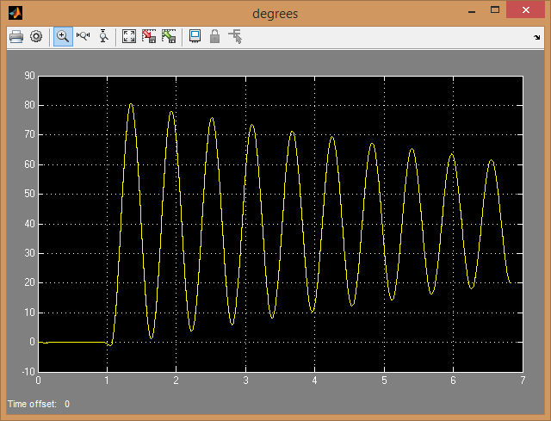

From this we can plot the points on this graph and get a frequency of 1.677 Hz which after placing back into the same formula would give us a moment of inertia of J = 0.0001331. These numbers are very close to the values we calculated and any error we find can be attributed to the fact that we assume the natural frequency to be the same as the damped frequency which we know is not equal but close in this case.

## Questions

1. Jp expected = 0.0001364
2. J = 0.0001331, f = 1.677
3. There is a minor discrepancy between the two, most likely due to the fact that we assumed the natural frequency to be the same as the damped frequency which is not true.

## Conclusion

This lab resulted in some very accurate results. We saw how we could accurately calculate the moment of inertia from knowing the basic specifications of the pendulum. Also we saw how we can get the moment of inertia from the output of the pendulum itself.